Theme: Natural World
Listening, Attention and Understanding
Attention Autism – Phases 1 and 2
Intensive Interaction
Listening to stories
Tacpac

Speaking – encouraging and developing talk
Makaton key signs: hello, good morning, more, finished, snack, lunch, happy, sad, toilet, later, waiting, stop, how are you today
Visual timetables with a now and next approach. Communication books
Expressive: Requesting desired items: CVB’s, PECS, Gestures, Vocalisations etc
Receptive: Learners following instructions containing 1 / 2 key words. Blanks level 1 “Naming questions.”
Showing pleasure / displeasure when interacting with a range of sensory resources.

My Communication
My Body: Physical Development
Reading:
Learners focusing on immersive sensory stories related to the Natural World.
Listening and interacting with familiar stories
Repeating rhymes and sounds
Phonics: Immersive experience of:
K, CK, E, U, R, H
Writing:
Pre-writing skills/shapes
Mark making – developing understanding that marks have meaning.

Knowing the marks they make have value.
Enjoys the sensory experience of mark making using a variety of resources and tools
Learners express interests in particular writing tools

My Thinking: Literacy
Reading
Numbers:
Matching, Sorting and Sharing: Continuous provision approach that exposes learners to key vocabulary through multi-sensory approaches.
Sharing Levels:
- Individual
- Small Groups,
- Peer Sharing
Shape, Space and Measures
Shape: Learners will develop their understanding of Shape via the context of our Natural World theme.
- Exploration of basic 2D (Circle, Square, Rectangle, Triangle)
- Immersive shape experiences
- Sorting by criteria (Same and everyday objects)

Exploring Patterns: Learners introduced to the concept of patterns, experiencing through multi-sensory approaches that can involve resources such as shapes, colours, actions and sounds etc.

My Thinking: Maths
My Wellbeing: Creative Art
My Thinking: Science

Discover Pathway
This term pupils will have the opportunity to learn…

Nature Art
Learners will create artistic designs, based around the theme of the Natural world, using different artistic methods.
- Nature Painting,
- Nature Printing,
- Insect Art,
- Leaf Art,
- Sand / Mud Art

My Wellbeing: LfL
Links to Literacy Stories
The Snail and the Whale: Self-Awareness
- People who are special to us - Identify people who are special to us (SA 4):
- Getting on with others - Demonstrate positive ways we can let people know how we are feeling (SA 5)
Sharing a Shell: World I Live In
- Respond with curiosity about the differences between people (WILI 1)
- Respond to the different pets / animals and ways of caring for them (WILI4).

PSHE: Class Timetable
Managing Feelings
MF1: Identifying and expressing feelings
- Respond to different facial expressions representing different emotions,
- Identify that make us feel happy.
MF2: Managing Strong Feelings
- Identify ways of communicating needs to others.

These concepts will be interwoven through learning activities and opportunistic learning, utilising learner preferences and motivations.

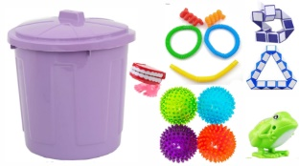

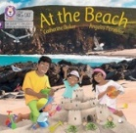
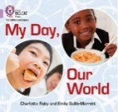
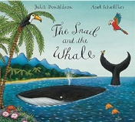

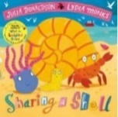
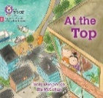
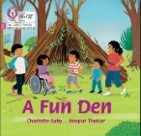

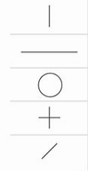
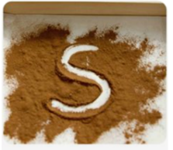

Habitats:

Multi-sensory approaches that enable learners to connect with the different habitats…
- Aquatic,
- Forests (inc. Jungle),
- Deserts,
- Grasslands,
- Mountains

Sequence of Lessons
- Sensory Exploration of habitats,
- Recreating habitats,
- Identifying habitats linked to Habitats,
- Simple Scientific Experiments,

Swimming: Water Confidence / familiarisation, shared and joint interactions in swimming pool.
Fine Motor Skills
Activities that develop fine motor skills, link closely to the Creative Art lessons. Skills aiming to develop pre-writing skills and independence when manipulating resources with hands and using one-handed tools. Skills include:
- Painting,
- Printing,
- Using Utensils: cutting with knife, scooping with spoon, stabbing with fork,
- Picking up objects between thumb and fingers

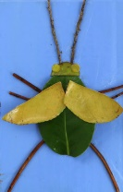
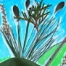
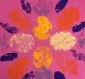

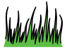
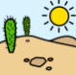
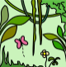
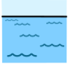
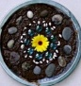
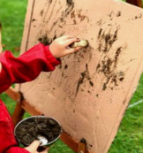
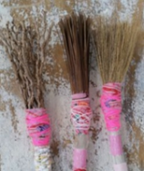
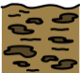
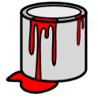
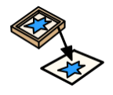
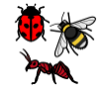


Summer Term 2024
Breadth of study
Learners to generalise key learning in the classroom outdoors…
Communication
Creative Arts: Using natural resources to
Create designs
Science: Multi-sensory exploration of the
outdoors related to habitats
Physical Development: Fine Motor Skills
Maths: Matching, Sorting, Sharing
PSHE: Managing Feelings

Staff to look for opportunities to embed key learning when learners are outside the classroom.

Learners will explore the theme of Natural World through exploring foods linked to the key habitats. Emphasis on…
- Learner interactions and exploration the different foods,
- Processes over the final product,
- Independence when creating different foods
- Expression of pleasure / displeasure
- Messy Munch
- Fine Motor Skills: Cutting / Chopping
Example Foods:
- Aquatic: Different fish
- Forest /Jungles: Fruits: Berries, avocado
- Desert: Plants and Squash, Dates, Raisins
- Grasslands: Cereals, Green Fruits and Vegetables,
- Mountains: root veg, Frozen Foods, Ice

Learners will have the opportunity to develop key skills that will prepare them for adulthood and to become active members of society. Emphasis on:
- Sharing Joint Interactions,
- Exploring the world outside the classroom,
- Following their interests,
- Building on their unique skills,
- Expressive and Receptive communication.
- Development of key life skills
Look for opportunities to take learners into the community – explore different habitats e.g. grasslands, farms, forest areas.

My Body: Outdoor Learning
My Body: Cooking
My Community
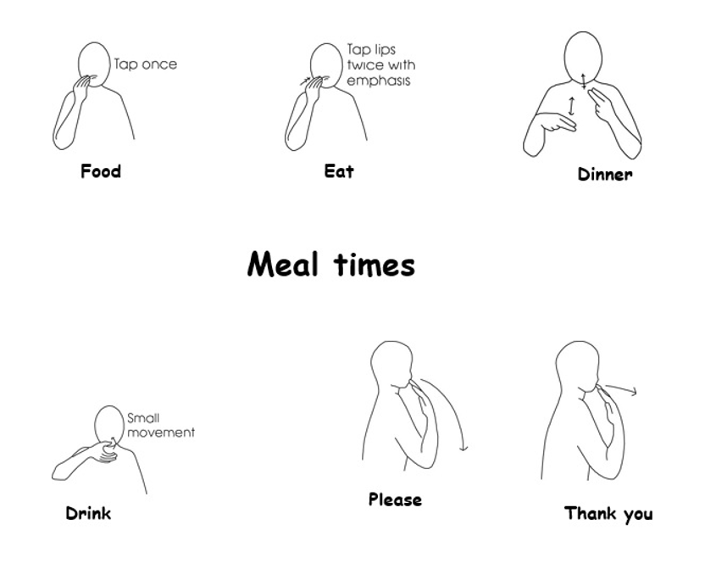

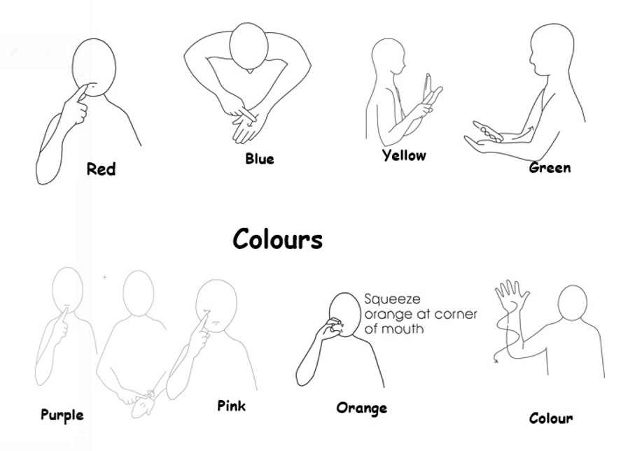
Key Makaton

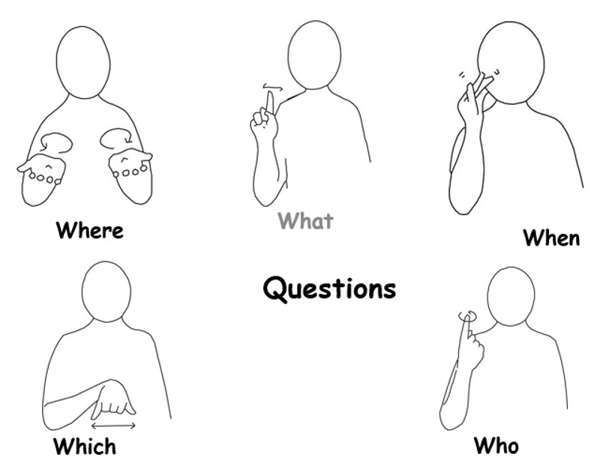
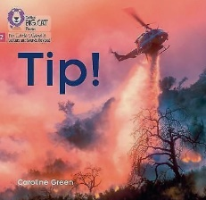
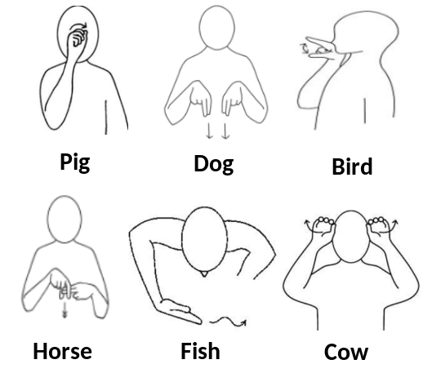

Key texts

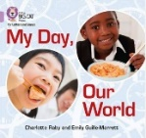

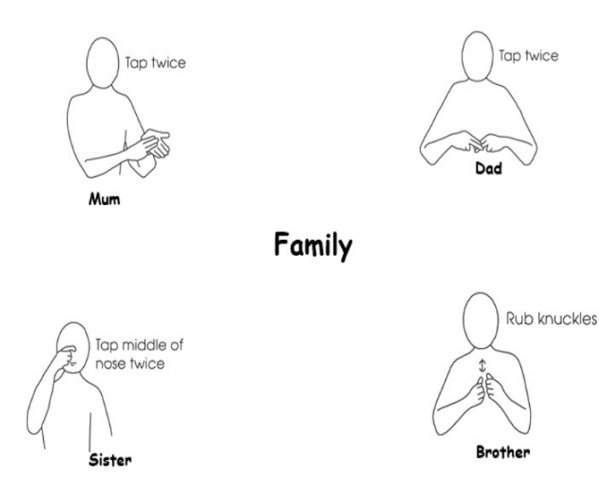
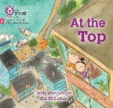

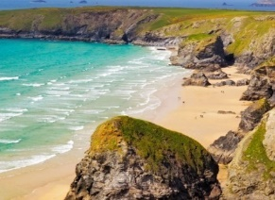

Key Questions embedded in all lessons:
Linked to key vocabulary within the Engagement Model:
- How do learners demonstrate they want to find out more (Exploration)?
- How do learners demonstrate that what they are doing matters (Persistence)?
- How do they show they know what is coming next (Anticipation)?
- How do learners show they want something to happen right now (Initiation)?
- How do learners show that something has grabbed their attention (Realisation)?

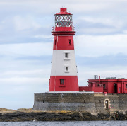
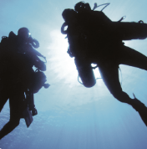


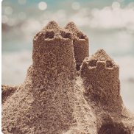

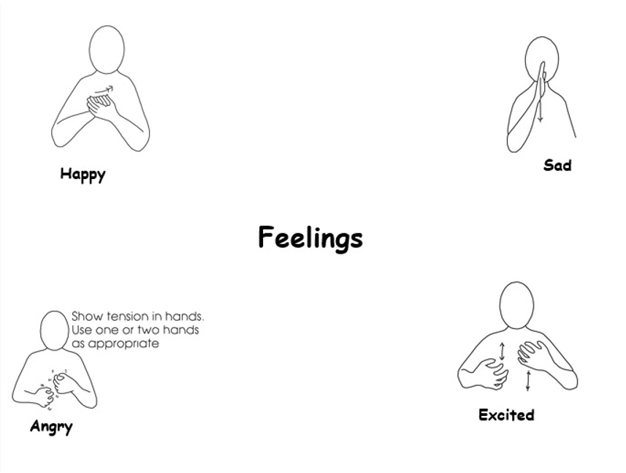
Autumn Term 2022
This theme is also personalised for each pupil to meet their outcomes in each pupil’s My Journey

